Project Report Template

### INTRODUCTION

* 1. Overview

The Tableau Subscriber galore is a framework designed to measure and evaluate the world’s Most top Youtube channels with an organization. It provides the top youtube channels and subscribers gator and Analyse the performance related to trending, contents, Back And development.

The Youtube consists of four main perspectives:

* 1. The origin or cause for making the first video: It has very little with you as the creator you can be charismatic, funny, and smart but if you don’t provide value, your videos are useless it’s not about you or what you can gain. If you show up to YouTube looking to get something out of it, you probably won’t be very successful. You need to focus on your audience. Not Yourself.
  2. The objectives that they achieve by continuing to make videos: When it comes to YouTube, video Keyword research is SUPER important. In fact, choosing the right keyword can Make or break the performance of your Video. For example, one video from my Channel ranks #1 in YouTube for “YouTube Views”
  3. The negative consequences of the experience: Community posts can include polls, quizzes, GIFs, text, images, and video. Community posts Can allow you to connect with your audience Outside of video uploads. They show on the community tab, and may show on Home or the Subscriptions feed.
  4. The perception of Community: YouTubers often deal with getting cancelled Sometimes it’s for serious things, like harmful or Insensitive comments or actions. Or, it could be Because of silly things, like your opinions on the Latest Star Wars movie. Whatever the reason, you Have to know that a cancelation lurks around the Corner at any given moment.

**1.2 PURPOSE**

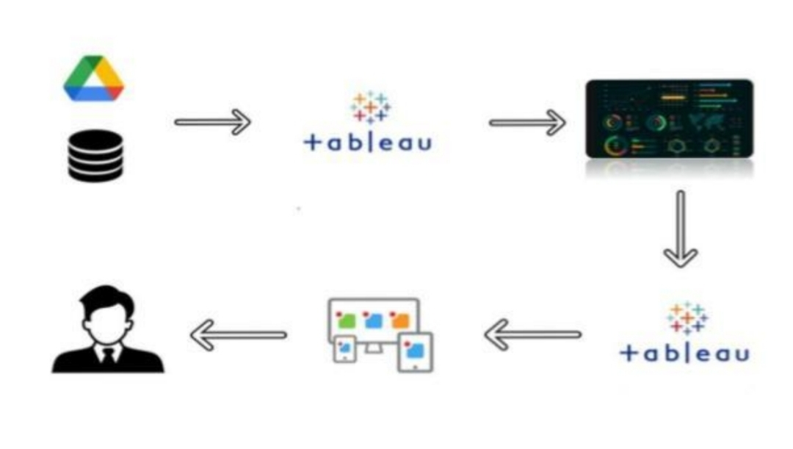

### Problem Definition & Design Thinking

**2.1 Empathy Map**

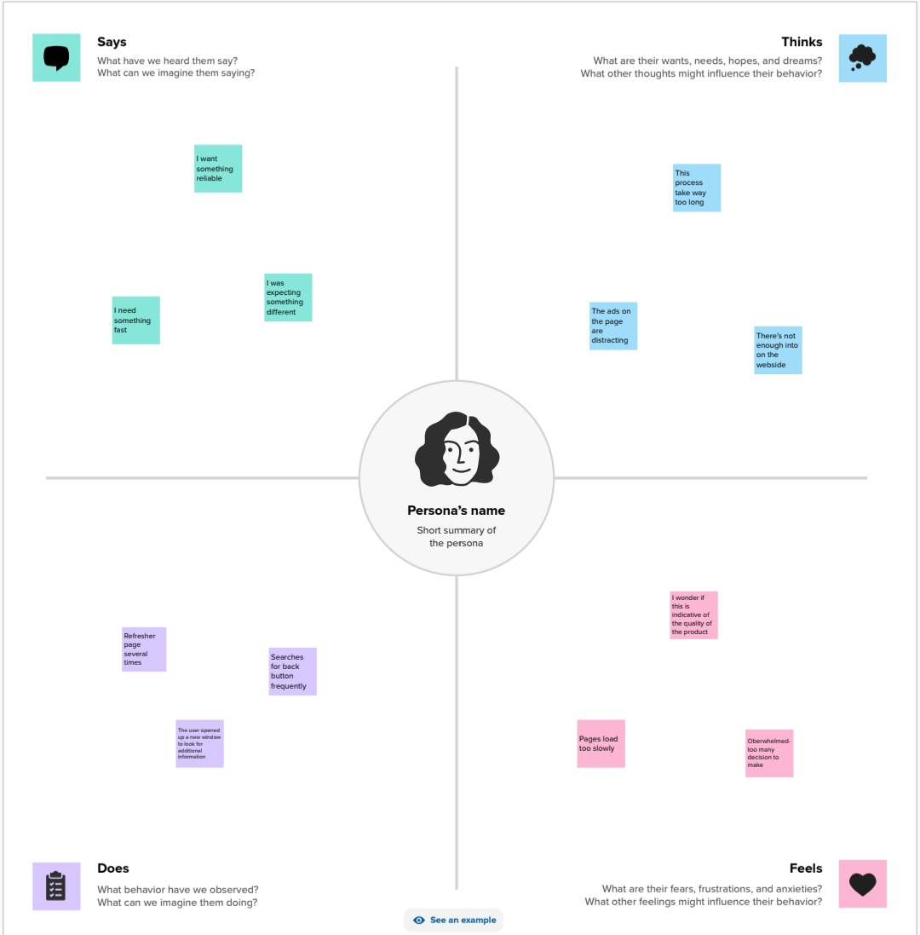

**Certainly! When creating an empathy map focused on feelings, we aim to understand and Capture the emotional experiences and reactions of the individuals involved. Here’s how it Might look for stakeholders in the context of the Subscribers Galore : Exploring World’s Top Youtube Channels:**

1. **\*\*Happiness**:**

**When talent management efforts yield positive outcomes and contribute to organizational success.**

**When their team members thrive, grow, and achieve their career goals.**

**When recognized for their achievements and provided with growth opportunities.**

1. **\*\*Challenges**:**

**When struggling to gather and interpret relevant data for effective talent Management decisions.**

**When faced with talent-related issues and lack of insights to address them Adequately.**

**When feeling overlooked or undervalued despite putting in significant effort.**

1. **\*\*Anxiety**:**

**When unsure about the effectiveness of implemented talent management Strategies.**

**When uncertain about making the right decisions regarding talent allocation and Development.**

**When uncertain about their career growth within the organization.**

1. **\*\*Contentment**:**

**When seeing positive trends and improvements in talent retention, development, And satisfaction.**

**When their team members are content, engaged, and motivated, leading to better Productivity.**

**When feeling content with their work, growth, and contributions being acknowledged.**

**Understanding these emotional aspects helps in tailoring the Explore Youtube channels and associated Strategies to address and positively influence the feelings and experiences of all Stakeholders involved in talent management.**

**2.2 Ideation & Brainstorming**

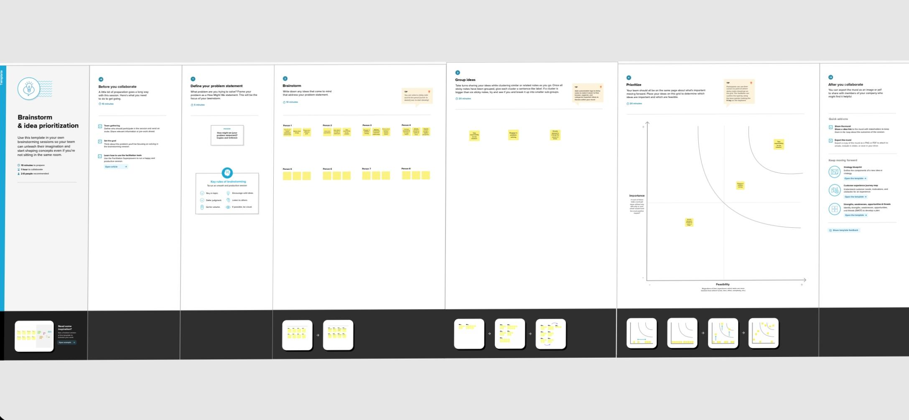

* Brainstorming is a group problem-solving method that involves the spontaneous contribution of creative ideas and solutions. This technique requires intensive, freewheeling discussion in which every member of the group is encouraged to think aloud and suggest as many ideas as possible based on their diverse knowledge.
* Brainstorming combines an informal approach to problem-solving with lateral thinking, which is a method for developing new concepts to solve problems by looking at them in innovative ways. Some of these ideas can be built into original, creative solutions to a problem, while others can generate additional ideas.
* Some experts believe that brainstorming is better than conventional group interaction, which might be hindered by group think. Group think is a phenomenon that occurs when the team’s need for consensus overshadows the judgment of individual group members.
* Although group brainstorming is frequently better for generating ideas than normal group problem-solving, several studies have shown that individual brainstorming can produce better ideas than group brainstorming. This can occur because group members pay so much attention to others’ ideas that they forget or do not create their own ideas. Also, groups do not always adhere to good brainstorming practices.
* During brainstorming sessions, participants should avoid criticizing or rewarding ideas in order to explore new possibilities and break down incorrect answers. Once the brainstorming session is over, the evaluation session (which includes analysis and discussion of the aired ideas) begins, and solutions can be crafted using conventional means.
* Common methods of brainstorming include mind mapping, which involves creating a diagram with a goal or key concept in the centre with branches showing subtopics and related ideas; writing down the steps needed to get from Point A to Point B; “teleporting” yourself to a different time and place; putting yourself in other people’s shoes to imagine how they might solve a problem; and “superstorming,” or using a hypothetical superpower such as X-ray vision to solve a problem.

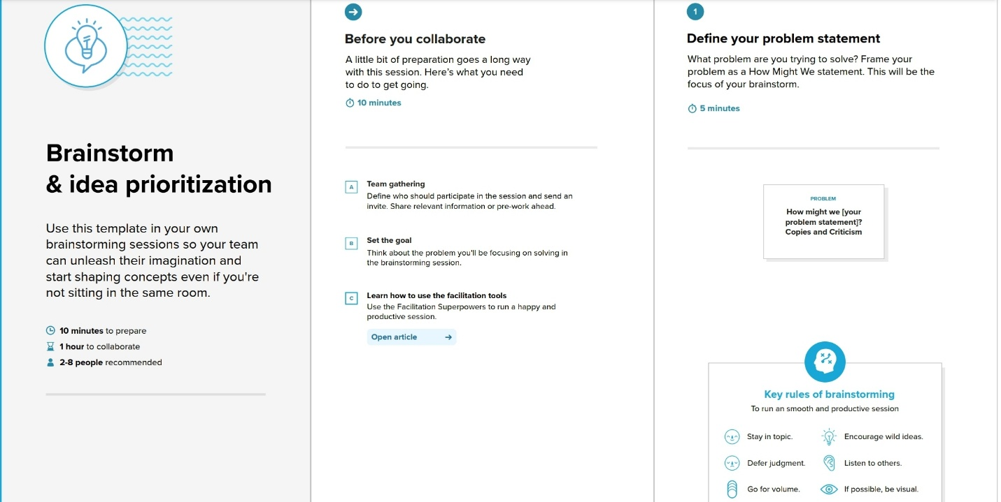

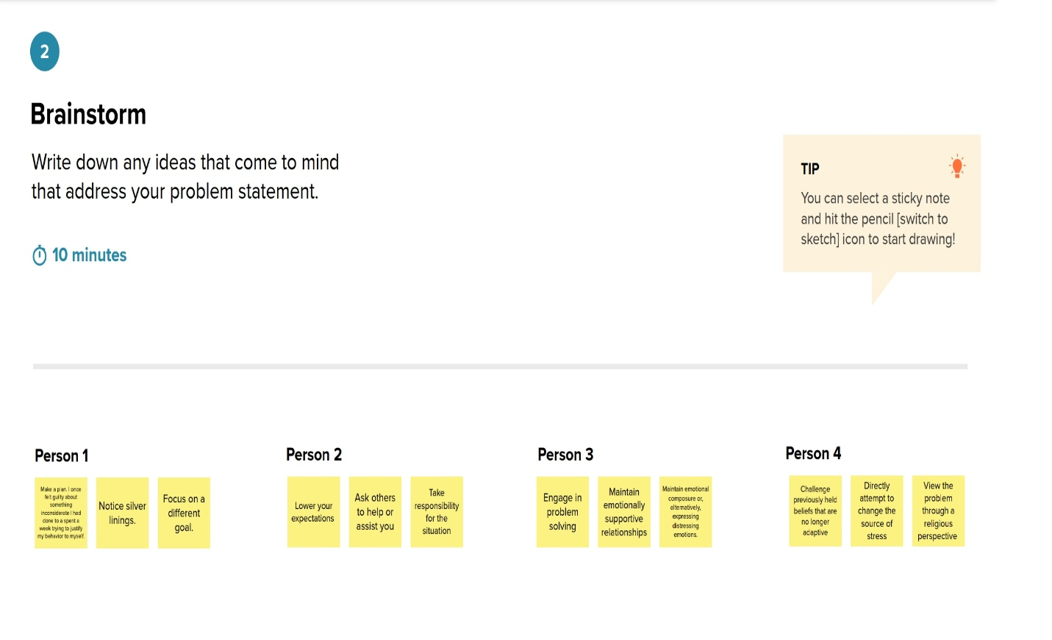

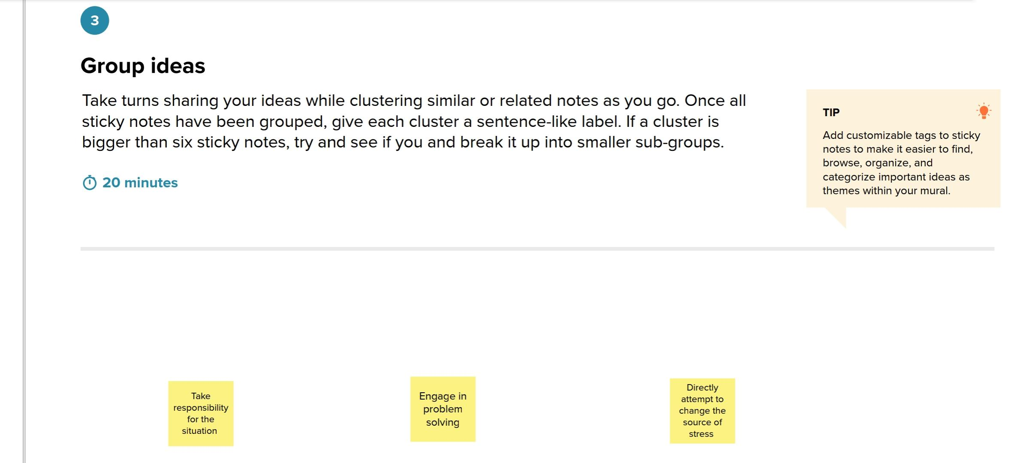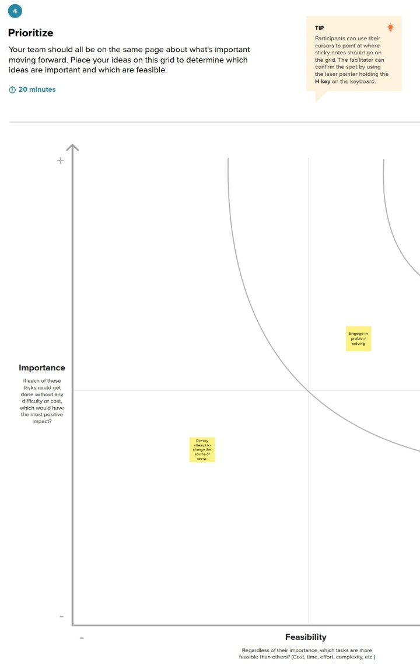

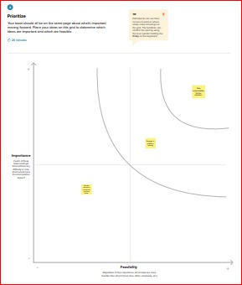

### RESULTS

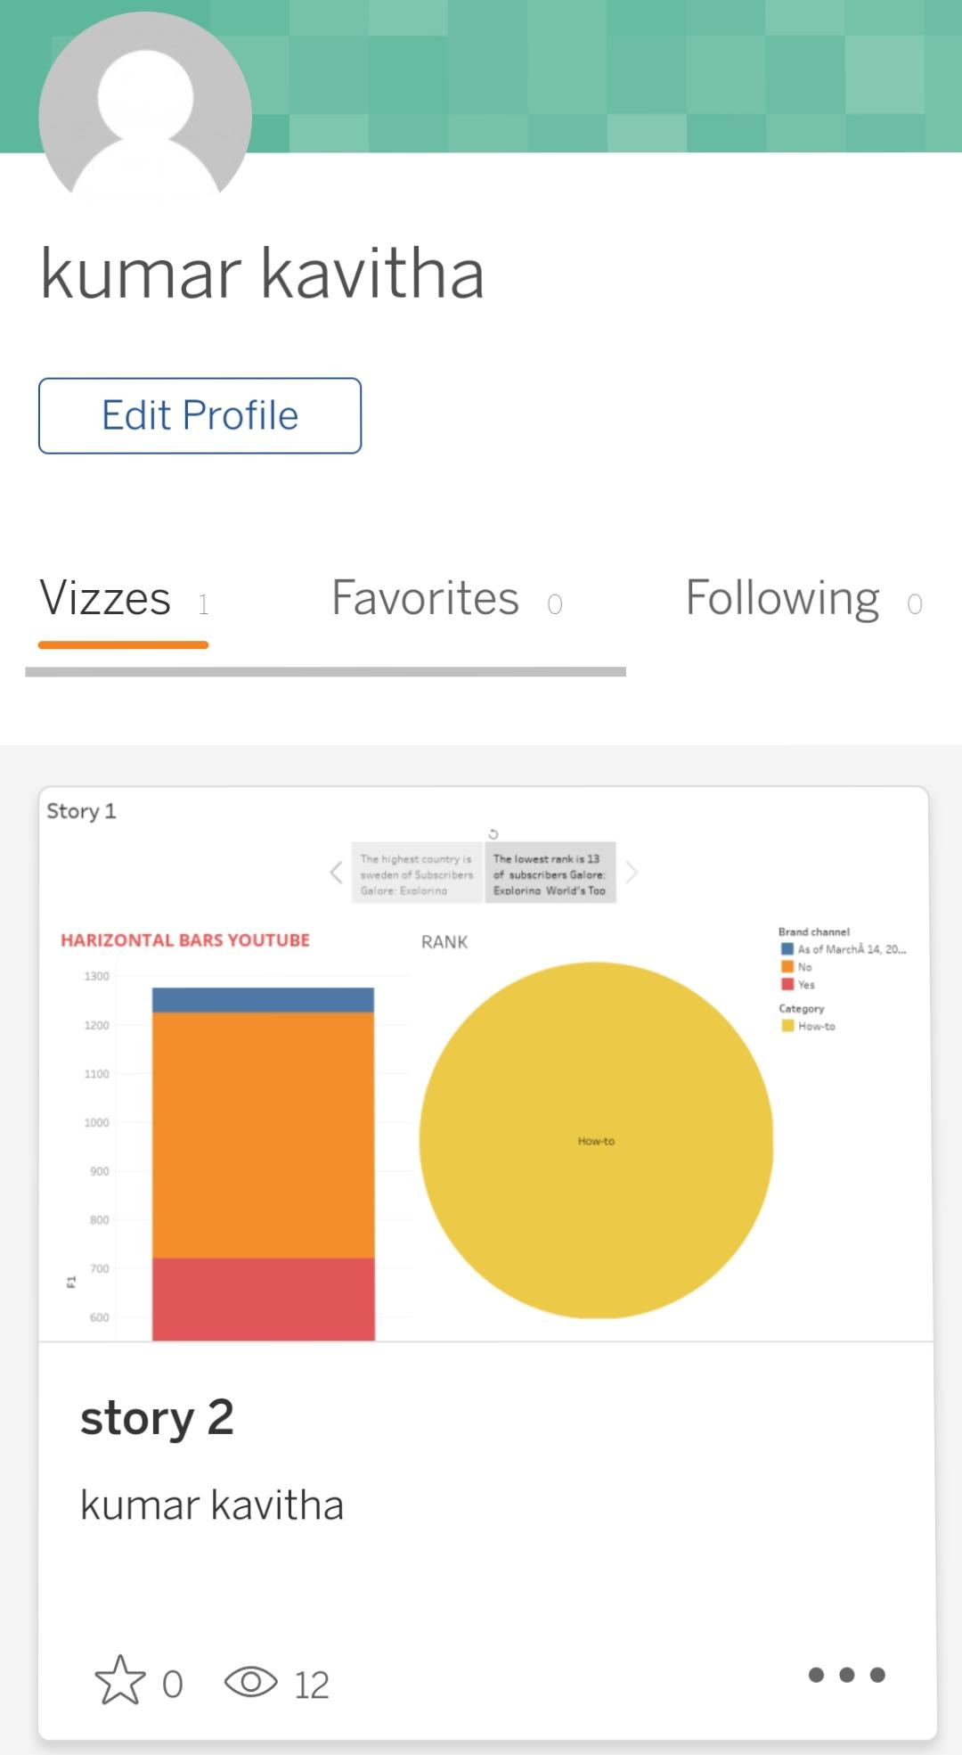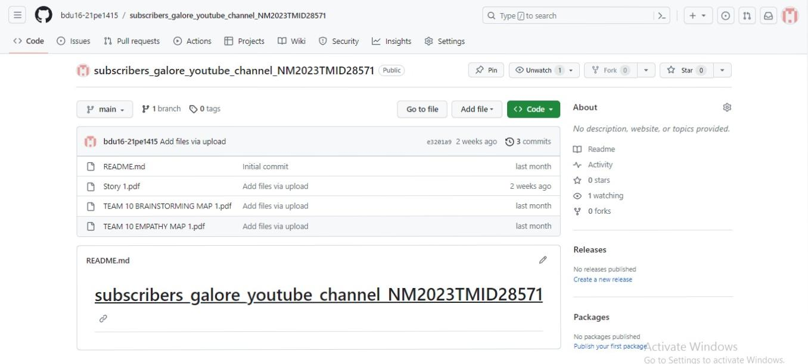

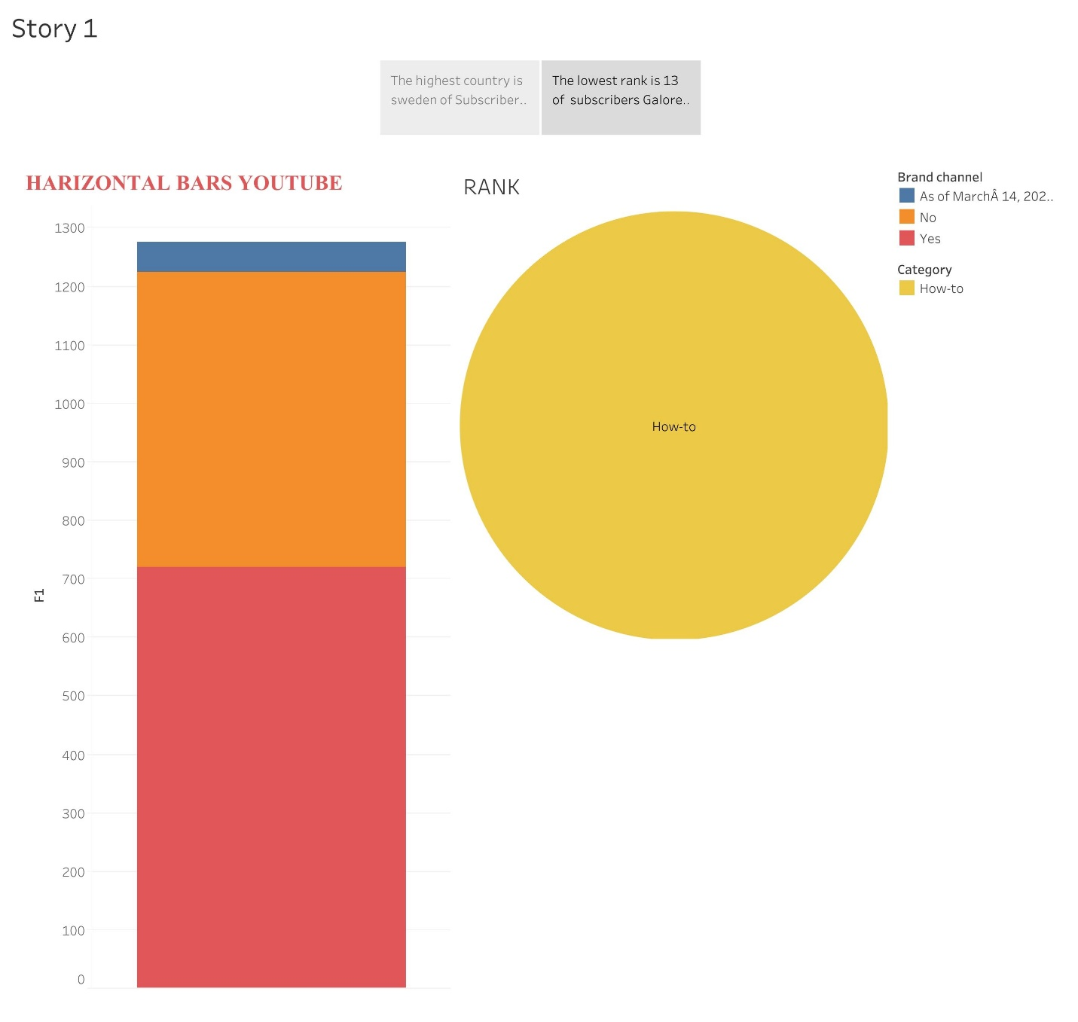

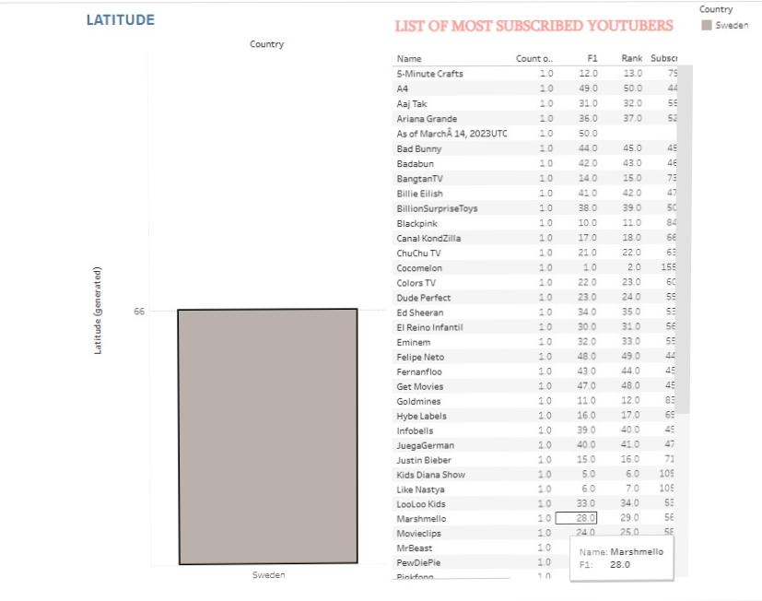

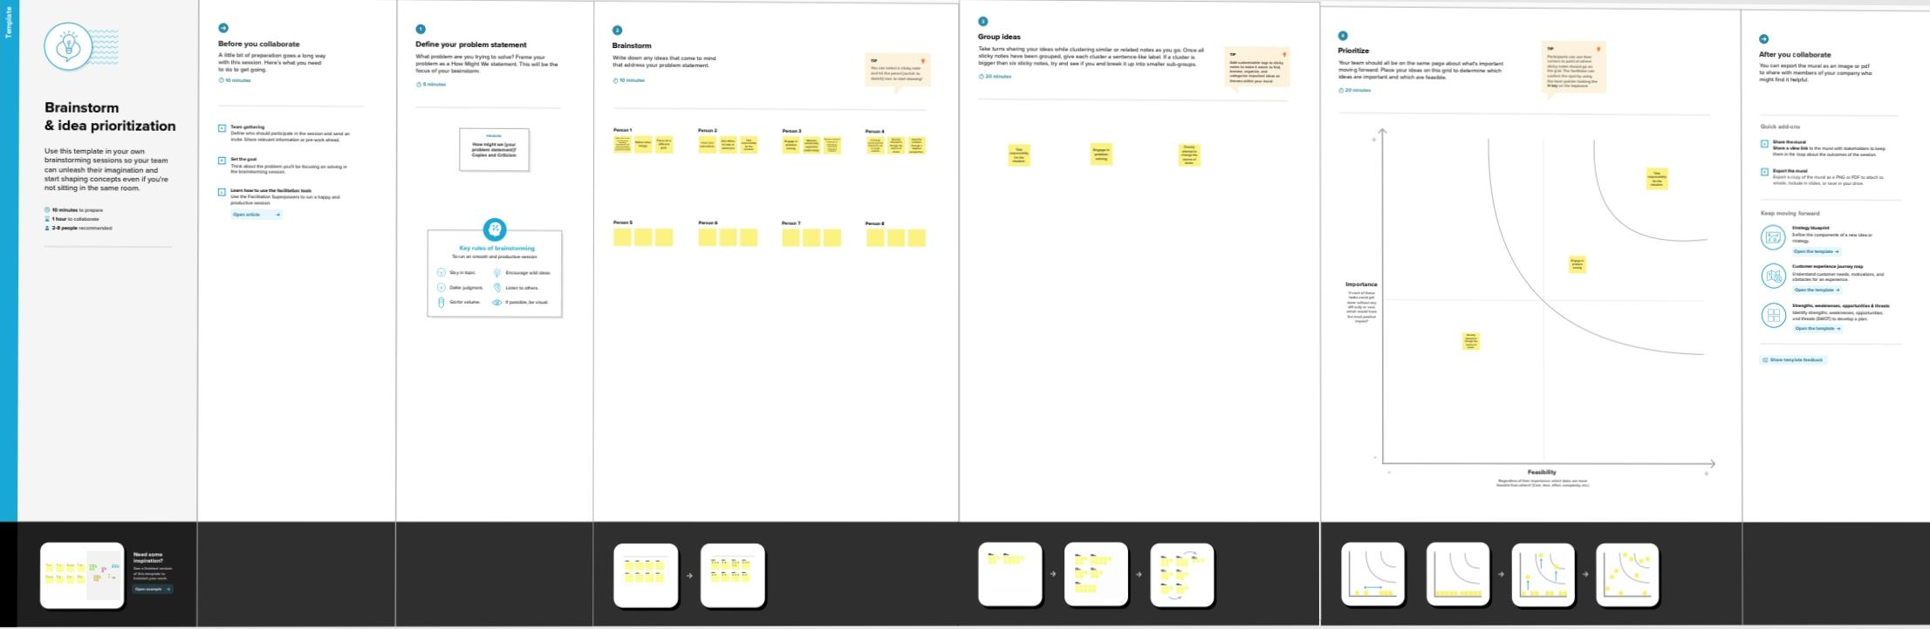

### ADVANTAGES &DISADVANTAGES

**3.1 ADVANTAGES**

**There are several advantages of YouTube:**

1. **It’s free to use: You can watch and upload videos on YouTube. However, to get the free services, now, you have to manage several advertisements, most of which can skip, but some of which need to play partially or wholly. YouTube Premium is a paid service that allows users to go ad-free.**
2. **Wide selection of content: There is a wide variety of content available on YouTube, including music videos, educational videos, movie trailers, and more, as we have mentioned above. The range is such that people have made entire careers by being YouTube content creators in several niches.**
3. **Accessibility: You can access YouTube from any device with an internet connection, including your computer, smartphone, and tablet. It brings knowledge of the world, such as Ted Talks, to your room. You can even rent movies on YouTube.**
4. **Ease of use: YouTube has a user-friendly interface that makes it easy to find and watch videos. It even remembers your past viewing history and recommends similar videos.**
5. **Sharing: You can easily share videos from YouTube on social media and other websites. Additionally, while downloading videos from YouTube to your device is difficult, you can view downloaded videos offline on the YouTube platform and share their links with your friends and family.**
6. **Environmental Sustainability: YouTube has made efforts to reduce its carbon footprint by using renewable energy sources and increasing energy efficiency. However, it is still a large consumer of energy.**

**3.2 DISADVANTAGES**

**However, there is nothing as a free lunch, and thus, it is only natural that there are also some disadvantages to using YouTube. Some of the disadvantages of using YouTube are as follows-**

1. **Quality and Copyright: The quality of videos on YouTube can vary significantly as not all videos create professionally, and some are pirated from other places and uploaded to YouTube.**
2. **Misinformation: Some videos on YouTube contain misinformation or false information. Fact-checking information you find online, including those on YouTube, is essential. Taking the lead from personal vlogs can be exceptionally dangerous as that information can be precise to the people involved and might not be the best for you as an individual.**
3. **Inappropriate content: While YouTube has strict policies to remove inappropriate content, some videos may not be suitable for all audiences. YouTube has a feature that helps keep children away from adult content.**
4. **Advertisements: Some users may find YouTube ads annoying or intrusive as these adverts often appear in the middle of a video and can take one away from the story involved.**
5. **Privacy: YouTube collects data from its users and may share it with third parties. It is a concern for users who value their privacy. Ads are also a concern of privacy issues, as some adverts that YouTube gets are from websites that have used cookies to remind users to return to their products.**
6. **Environmental Sustainability: YouTube uses significant energy to support its operations, including the servers and data centers needed to store and transmit video content.**
7. **Social sustainability: YouTube has faced criticism for its impact on its users’ mental health and well-being, particularly young people. While this remains a problem, YouTube has implemented policies and tools to address these issues from now on.**
8. **Paying Its Creators: While YouTube has been successful as a business, with solid growth in revenue and profits, there have been concerns about the fairness of the revenue-sharing model for creators. Furthermore, some people have expressed concerns regarding using algorithms to recommend content, which can have unintended consequences for creators and users.**
9. **Creating an echo chamber: Like many other apps and websites on the internet, YouTube works on an algorithm. This algorithm sometimes recommends to users the kind of content they have engaged with before, and this can sometimes lead to the creation of an echo chamber where you repeatedly hear the same rhetoric and the same creators. However, this only happens sometimes and is more expensive than YouTube.**

### APPLICATIONS

* **Main Functions of YouTube**
* **Users can search for and watch videos**
* **Create a personal YouTube channel**
* **Upload videos to your channel**
* **Like/Comment/share other YouTube videos**
* **Users can subscribe/follow other YouTube channels and users**
* **Create playlists to organize videos and group videos together**

## Teens Like YouTube

**YouTube is a free to use service** and a can be a great space for teens to discover things they like. For many young people, YouTube is used to watch music videos, comedy shows, how to guides, recipes, hacks and more. Teens also use the video-sharing service to follow their favourite vloggers (video blogger), subscribe to other YouTubers and celebrities they are interested in.

AGE RESTRICTIONS

To set up a YouTube account users must be 18 years of age or 13+ with parental consent.**Under the new E.U General Data Protection Regulation (GDPR), Ireland has now set the Digital Age of Consent to 16 years old. This means young people under the age of 16 in Ireland are not allowed to access this platform.**

However, users do not need to sign-in to access the website or to view videos. There is, however, a YouTube kids version now available to download for free. YouTube kids is designed for children aged  3-8 years old and make it easier for children and parents to find content they are interested in.

CYBER BULLYING

Unfortunately, people can experience negative comments and bullying on the service particularly through the comments function (YouTube users can comment on other users videos). If your child has a YouTube channel/profile it might be a good idea to recommend they disable comments on their own profile/channel. This can be done very easily via settings and helps minimise risk of experiencing negative comments. If your child is experiencing harassment on YouTube, you can block and report users.

**TIPS FOR KEEPING YOUR CHILD SAFE ON YOUTUBE**

Managing Privacy Settings

When a user uploads a video to YouTube, by default the video is set to public, which means anyone can see the video. Depending on the age of your child, you should discuss what settings are best to use if your child is uploading footage to YouTube. You can easily switch videos to private or unlisted (published on YouTube but cannot be found without a direct link to the video). You can also invite people to view your videos using Google Circles. Please note, you need to link your channel with Google+ in order to share a private video with other users.

Set up Parental Controls Parents should set up age restrictions and parental controls on YouTube. Disable Comments on YouTube YouTube allows you to disable comments entirely on videos or users have the options to approve each comment before they are published, this can help avoid risks of experiencing cyberbullying. See how to disable comments.

Use Safety Mode

YouTube has a Safety mode, a setting which gives users the opportunity to bar mature content. It is an “opt-in” setting, which means that it won’t take effect until you switch it on. The setting filters search results to remove videos with mature content or videos that have been age-restricted, meaning that such content will not show up in video searches, related videos, playlists, shows or movie sections. While no filtering system is 100 percent accurate, we recommend that parents of young children enable this feature.

Useful Links:

YouTube Family Link allows you to control settings on YouTube Kids including the content level setting you want for your child, and if you want your child to use the search functio

**In 2021 YouTube introduced *Supervised Experiences on YouTube***. This feature is for parents who want to allow their child to transition from YouTube Kids to supervised access to the main YouTube platform. Via a Supervised Google Account the feature will offer parents the ability to choose from 3 different content settings on YouTube.

**Explore:** For children ready to move on from YouTube Kids and explore content on YouTube, this setting will feature a broad range of videos generally suitable for viewers ages 9+, including vlogs, tutorials, gaming videos, music clips, news, educational content and more.

**Explore More:** With content generally suitable for viewers ages 13+, this setting will include an even larger set of videos, and also live streams in the same categories as “Explore.”

**Most of YouTube:** This setting will contain almost all videos on YouTube, except for age-restricted content, and it includes sensitive topics that may only be appropriate for older teens.

### CONCLUSION

In conclusion, the Tableau Explore Youtube channels emerges as a powerful tool in the realm of Talent management, offering a comprehensive approach to measure success. Its Strengths lie in advanced data visualization, real-time monitoring, customization, and Seamless integration, facilitating informed decision-making and strategic alignment. However, challenges such as implementation costs, a learning curve, and potential data Complexities need consideration. Caution is warranted to prevent an overemphasis on Quantitative metrics, potentially overshadowing qualitative aspects.

### FUTURE SCOPE

Based on current trends and developments, here are Some potential scenarios for the future of YouTube In the next five years:

Continued growth and expansion: YouTube Has already experienced tremendous Growth in recent years, and this trend is Expected to continue. With over 2 billion Monthly active users and increasing Consumption of video content, YouTube is Poised for continued growth in the coming Years.

More original content: YouTube has been Investing heavily in original content through Its YouTube Originals program. This trend is Expected to continue, with YouTube Potentially increasing its investment in Original content to compete with other Streaming services like Netflix and Hulu.

Increased focus on monetization: As YouTube faces increasing competition from Other platforms, it may focus more on Monetization to remain competitive. This Could mean more advertising on the Platform or new monetization options for Creators, such as paid subscriptions or Merchandise sales.

Continued push towards Al and machine Learning: YouTube has been using Al and Machine learning to improve the user Experience, such as recommending videos And improving search results. This trend is Expected to continue, with YouTube Investing in more advanced Al technologies To enhance the platform further

Increased regulation and moderation: YouTube has faced increasing scrutiny over The years, with concerns over content Moderation and the spread of Misinformation. In response, YouTube may Continue to invest in content moderation Technologies and policies to address these Concerns.

### APPENDIX

Reference

* <https://public.tableau.com/app/profile/kumar.kavitha/vizzes>
* https://github.com/bdu16-21pe1415/subscribers_galore_youtube_channel_NM2023TMID28571